Severe Weather Incident – November 2015
Appendix A
Introduction
Following notification on 12th November from the Met Office, the Emergency Planning & Resilience Service were involved in a severe weather incident over the weekend of 14th and 15th November. The Met Office issued an amber warning with a medium likelihood of significant river and surface water flooding impacts in parts of Lancashire.
Leading up to the weekend
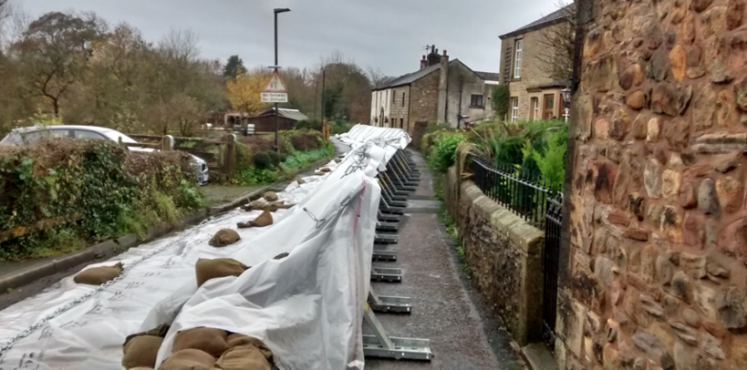
Due to the likely impacts of the severe weather, the Strategic Coordinating Group (SCG) meeting on Friday 13th declared a major incident under the Civil Contingencies Act 2004. Declaring a major incident allows multi-agency partners including local authorities, emergency services and environment agency to coordinate their response together through the SCG. The top priorities for the SCG were to minimise risk to the public, maximise safety to the public and responders, work together to contain the emergency, warn and inform the public effectively and to ensure critical services to local communities are maintained.

One of the decisions from the SCG on Friday 13th was to set up a countywide Tactical Coordination Group (TCG) which would link to the SCG and into local TCG's in the most affected areas across Lancashire. Coordination at the local TCG was important, with the Districts, Police Flood Liaison Officers and LCC Highways Service working together to monitor the surrounding areas.
The LCC response had begun on the Friday 13th with coordination between Emergency Planning & Resilience, Highway Services, Flood Risk Management and Customer Contact Centre in preparation for the weekend to minimise the risk to local communities. Emergency Planning & Resilience had also given prior notice to the Emergency Response Group and the voluntary agencies regarding events over the weekend.
Saturday 14th November
As the weather conditions deteriorated on Saturday, the Environment Agency issued five flood warnings with the likelihood raising to severe flood warnings in Padiham, Ribchester and Whalley. Due to the uncertainty whether the flood warnings would rise to severe flood warnings, temporary flood defences were set up coordinated between the Environment Agency and the Military. The photographs above and below show the flood defences that were deployed around the affected areas in Ribble Valley.
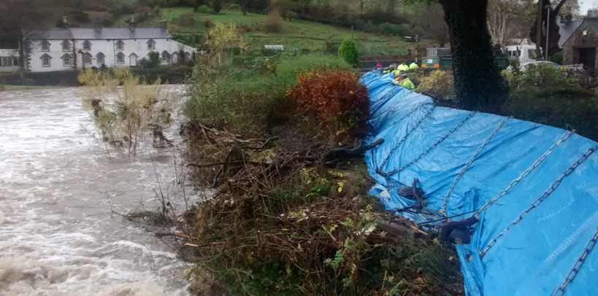

With the uncertainty of the rising to severe flood warnings, it was agreed at the countywide TCG to begin putting plans in place in case there was a need to evacuate residents later on in the evening. The areas most affected by the severe weather were Padiham, Whalley and Ribchester collectively having over 900 properties.
Coordination of the Rest Centres
This resulted in the coordination between Emergency Planning & Resilience and the local District Councils (Burnley and Ribble Valley Borough Council) to activate 3 emergency rest centres at St Peters Leisure Centre, Longridge Civic Hall and Roefield Leisure Centre. Activating the rest centres meant requiring the support of the Emergency Response Group (ERG) - Lancashire County Council staff who on a voluntary base are able to staff the rest centres.
The ERG out of hours on call team leader was able to activate a core team of members to each of the rest centres, while Emergency Planning & Resilience activated the Emergency Support Unit (ESU) Vehicle which has key equipment for the ERG to use in the rest centre. The coordination of the rest centres went via the Emergency Planning & Resilience team to the out of hours on call team leader to the ERG members at the rest centre.
The activation of the rest centres also meant calls being made to eight different voluntary agencies for example such as British Red Cross and Salvation Army. The voluntary agencies were put on standby in case the rest centres needed support due to the volume of evacuees.
One of the decisions to be made was how to get the potential evacuees to the rest centres. This involved coordination between LCC Emergency Planning & Resilience and LCC Public Integrated Transport. Passing over the key details of what was required, the Public Integrated Transport team were able to put 7 x 52 seater coaches on standby in readiness of any evacuees that would be required to go to the rest centres. Discussions were also ongoing within regards to vulnerable persons and Public Integrated Transport had the potential to access Travelcare buses with wheel chair access. The picture below highlights the operation between Lancashire County Council services, Burnley Borough Council and Ribble Valley Borough Council by establishing which evacuees from the affected areas would go to which rest centre allowing for the transport to be divided between the three areas effectively.

Conclusion
Even though the flood warnings did not escalate to severe flood warnings, and the evacuation of residents from their homes was not required, to prepare for such an event needs to be coordinated and effective as services from all different organisations came together to plan and to minimise disruption to the local communities. The work done internally at LCC was well received and continued into Sunday and Monday where Emergency Planning & Resilience were liaising with LCC Highways and partner agencies in continuing to minimise the disruption on local communities.

